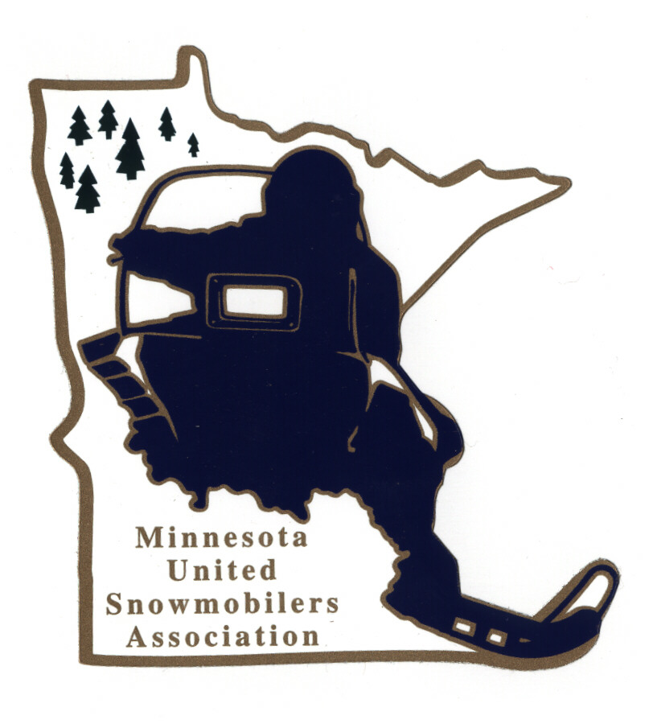
Minnesota United Snowmobilers Association

----- 2022 Dealer of the Year -----

7040 Lakeland Avenue North, Suite 212, Brooklyn Park, MN 55428
Office Email – mnusaoffice@popp.net
Charity/Awards Chairperson Janet Widness – jwstulk@prtel.com

MnUSA Charity & Awards Committee is proud to present 2022 Awards Program and will be presented at the 2023 Winter Rendezvous.

Nomination Requirements –
- A Snowmobiler Dealership that is deeply committed to organized snowmobiling and is involved with snowmobile organizations and strives to make the sport even more enjoyable in the future
- Must be a MnUSA member and/or business sponsor
- May be nominated by individual, snowmobile clubs/organization or by the nominee
- Must include responses to all topics addressed in this form (prefer typed)
- Include supporting documents, pictures, testimonials, etc.
- Must not have received this award within the last 10 years
- Submit to office and Committee Chairperson by mail or email no later than November 30, 2022

Judging and Notifications –
- Committee judges all applications and verifies if qualify
- All decisions of the committee are final
- Will be contacted by Chairperson if you have been accepted or not by mail or email

The winning MnUSA Dealer of the Year will also be submitted to American Council of Snowmobile Association (ACSA) National Award.

Thank you for submitting your nomination.

MnUSA Office and Charity/Awards Use Only

Date of Arrival Circle - By: Mail or Email

Certifies that applicant is a good standing MnUSA member:

MnUSA Officer Name/Title Signature

----- MnUSA Dealer of the Year 2022 -----

(can also type information in other program)

Dealership Name: MnUSA #:

Address: City: State: Zip:

Business Phone: Email:

Local Newspaper: City of Newspaper:

Nominated By Name:

Address: City: State: Zip:

Phone – Home or Cell: Email:

----- Dealer of the Year’s Profile -----

Dealer Is Active Member Of What Snowmobile Club(s):

How Many Years Been Active In Organized Snowmobiling?

Describe What Leadership Positions/Dates of Activity Holds and Has Held in a Club, Region, State and/or National Snowmobile Association:

Describe What Local, Regional, State and National Government Meetings Where The Dealer Has Been An Active Participant:

Name and Explain How The Dealer Participates in Club and Association Fund Raising Events (the fund raising does not have to be restricted to snowmobiling):

Describe How Does The Dealer Represent Snowmobiling and Snowmobilers at Club, Regional, State and National Activities:

Explain How The Dealer is involved in All Phases of Snowmobiling:

----- MnUSA Dealer of the Year’s Profile -----

Describe The Methods Your Nominee Uses To Introduce Non-Snowmobilers To The Sport:

Describe How and When Does The Dealer Introduce Customers To Organized Snowmobiling:

Describe How The Dealer Promotes Club Membership:

Describe Any Special Projects The Dealer Currently Participates In:

Give A Brief Summary About Your Nominee (200 words)

