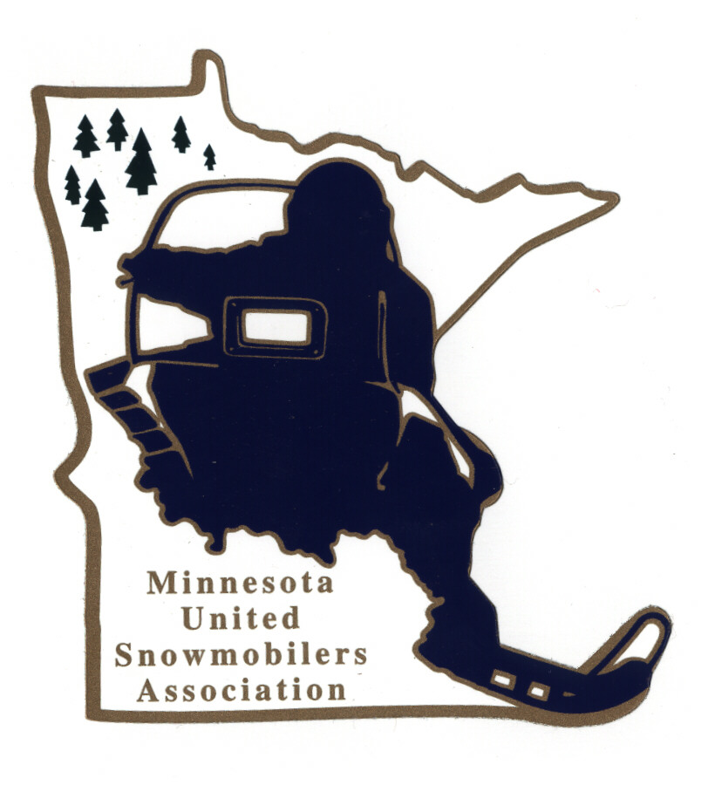
Minnesota United Snowmobilers Association

----- 2022 Young Snowmobiler of the Year -----

7040 Lakeland Avenue North, Suite 212, Brooklyn Park, MN 55428
Office Email – mnusaoffice@popp.net
Charity/Awards Chairperson Janet Widness – jwstulk@prtel.com

MnUSA Charity & Awards Committee is proud to present 2022 Awards Program and will be presented at the 2023 Winter Rendezvous. The future of our sports depends on the involvement of today’s youth. We have many young adults going the extra mile to help protect our sport.

Nomination Requirements –
- Youth Snowmobiler (age 12-18) who is deeply committed to organized snowmobiling and is involved with snowmobile organizations and strives to make the sport even more enjoyable in the future
- Family/Guardian must be a MnUSA member
- May be nominated by individual, snowmobile club/organization or by the nominee
- Must include responses to all topics addressed in this form (prefer typed)
- Include supporting documents, pictures, testimonials, etc.
- Must not have received this award within the last 8 years
- Submit to office and Committee Chairperson by mail or email no later than November 30, 2022

Judging and Notifications –
- Committee judges all applications and verifies if qualify
- All decisions of the committee are final
- Will be contacted by Chairperson if you have been accepted or not by mail or email

The winning MnUSA Young Snowmobiler of the Year will also be submitted to American Council of Snowmobile Association (ACSA) National Award.

Thank you for submitting your nomination.

MnUSA Office and Charity/Awards Use Only

Date of Arrival Circle - By: Mail or Email

Certifies that applicant is a good standing MnUSA member:

MnUSA Officer Name/Title Signature

----- MnUSA Young Snowmobiler of the Year 2022 -----

(can also type information in other program)

Snowmobiler’s Name: Age/Birthday

Address: City: State: Zip:

Phone – Home or Cell: Email:

Local Newspaper: City of Newspaper:

Nominated By Name:

Address: City: State: Zip:

Phone – Home or Cell: Email:

----- Young Snowmobiler of the Year’s Profile -----

Young Snowmobiler’s Club Affiliation:

How Many Years Been Active In Organized Snowmobiling?

Describe The Participation In Club and State Association Events:

How Did The Young Snowmobiler Become Involved In Organized Snowmobiling?

How Does The Young Snowmobiler Promote Involvement From Other Youth In The Organization:

What Suggestions Does The Young Snowmobiler Have For Getting The Younger Generation To Become More Involved In Organized Snowmobiling:

Give A Brief Summary About Your Nominee (200 words)

